March/April 2014

HOA President’s Letter

Homestead Neighbors!

Coming . . .

Sincerely,
Rusty Nejdl
Homestead HOA President

Board of Directors Meetings

We would like to thank the homeowners who have taken time out of their schedules to attend the Association’s most recent Board of Directors Meetings. These meetings are held in the clubhouse and we encourage homeowners to come out and hear first-hand what decisions are made by the Board Members. Being a Board Member is a very challenging position, which requires them to put on their thinking cap not only for themselves, but for the entire Association.

The next meeting is scheduled for March 17, 2014 at 7:00 pm, at the clubhouse. An e-mail will be sent out the week prior confirming the time, date and location.

Please come out and support your Board of Directors and your Association.

Do You Enjoy Volunteering?

We have two volunteer positions opened. One for Social Activities and the second for Newsletter Coordinator. To get started, contact Cheryl Brewer at HomesteadatCarrollton@gmail.com.

Contacts to Remember

Contact Information:
When you have a question or concern, use the following contact information to get assistance.

- Cheryl Brewer, HOA Administrator (ACC; violations; landscaping, irrigation or common area concerns; forms; clubhouse, pool cards, etc.): 972-261-9841 or homesteadatcarrollton@gmail.com.

- Sunday Wright, FirstService Residential (to initiate or escalate any concerns):
214-451-5429 or SunDay.Wright@fsresidential.com.

- The Homestead website (forms for clubhouse rental, ACC, pool cards; information on budgets, board minutes and more): www.homesteadatcarrollton.com.

- FirstService Residential Customer Service (billing problems, reporting issues, etc.):
877-378-2388.

FirstService Residential
3102 Oak Lawn Avenue, Suite 202
Dallas, Texas 75219

NEIGHBORHOOD GROUPS
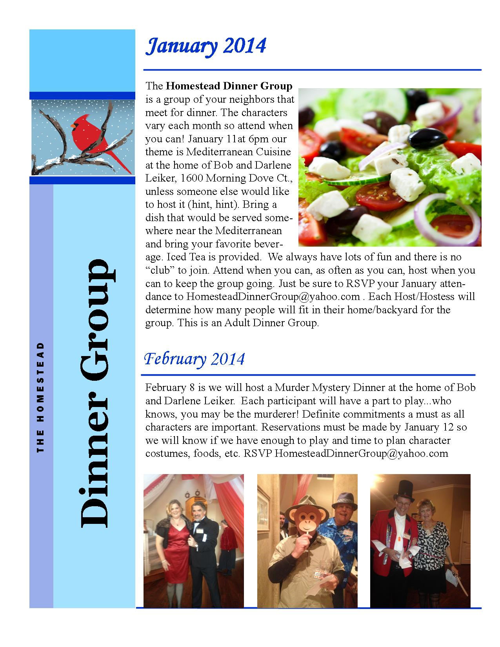

omestead aturday
oup & alad ocial
This is open to all women in the Homestead who would like to get together quarterly for a potluck lunch and spend time socially with their neighbors.

Meeting Months:

March 22, 2014
Host: Laura Bush & Jerry Davidson

May ___, 2014
Host:

The hope is to keep this simple and have time to visit with women in our neighborhood.

Please e-mail Lynn Rossol for more information: lynnrossol@hotmail.com or call 972-492-7698.

POKENO, BUNCO & POKER GROUPS
There are quite a few game groups in the neighborhood. These are terrific ways to have fun and get to know your neighbors. If you would be interested in joining or subbing for a group, contact:

Pokeno:
Diane Albright – ty.di@verizon.net – 972-492-5334 (meets 1st Thursday)
Deborah Tkach – tkachfamily@yahoo.com – 469-688-8845 (meets 2nd Thursday)
Laura Bush – llbush@me.com (meets 3rd Tuesday)

Poker:
Michael Businelle – busi26@hotmail.com (meets once a month)

If any other groups would like their contact information listed for people who might like to substitute or join a group, or if you would like to start a new group (it doesn’t have to be only Pokeno or Bunco), please submit that information to Cheryl Brewer, the HOA Administrator at 972-261-9841 or homesteadatcarrollton@gmail.com.

HOMESTEAD WOMEN’S BOOK CLUB meets on the second Wednesday of each month at 7:00 pm at the home of the hostess for the month. The books and hostesses for the next few months are:

March 19: Julie Van Horn - Wonder by R.J. Palacio

April 9: Jenny Stewart - Princess: A True Story of Life Behind the Veil in Saudi Arabia by Jean Sasson

May 14: Mary Ann Sassone and Stacey Wittrup, Book TBD

June 11: Debra Kerper

As always, snacks will be provided . . . but it is BYOB! Newcomers are always welcome! This is a wonderful way to get to meet your neighbors and make friends. If you have any questions, contact Lindsay Marchant at lmhill68@hotmail.com.

TEENS AT YOUR SERVICE

Please check your teen’s info for accuracy. Send updates to the Newsletter Coordinator or Cheryl.

Baby-Sitting
Hunter Rosson is available to babysit. She is 13 years old, first aid and CPR certified. She would love to help watch your children on the weekends. Phone 972-492-7114.
Allison Cash – 13 years old, 8th grade ACMS student. Trained in First Aid and CPR. Younger sister of Jennifer Cash Speer & Lisa Cash. Contact Allison at 972-492-6194 or cashfamtx@verizon.net
Rachael Fedash – 12 years old, 7th grade; loves toddlers and trained in CPR and First Aid. Available on weekends. Please call 972-492-7159.
Addie Lutz – I am a 17 year old Junior student at Hebron HS. I love kids and have experience babysitting all ages. I am responsible and would love to play with your children. Please call me on my cell at 214-906-2411. My parents are Lynne and David Lutz and I live at 1724 Bluffview.
Madeline Mentesana – 14 year old 8th grader with lots of experience with babies and toddlers. Call me at 972-307-1890 or 214-244-3590.
Leslie Short – 15 years old, a Sophomore at Hebron High; also a JV Cheerleader. Certified Babysitter: She has completed Safe Sitter courses at Plano Presbyterian, CPR and First Aid certified. 972-948-8533. 1709 E. Branch Hollow Drive.
Cameron Walker – High school student available for babysitting. Call me at 972-939-5436.

Pet/House Sitting & Yard Services
Adam Dreyer – 12 year old in middle school. Love all pets. Please call 972-394-6766 if you need a pet sitter.
Scotty Dye – Have pet sitting or lawn mowing needs? I am a college age student available summers to do mowing, trimming, yard work and Christmas break to do pet sitting. Size of lawn will determine cost. I am prompt and very responsible. References are available upon request. 972-394-1954 or tscottdye8@verizon.net.
Braeden Gould – 12 year old would love to watch your pet for you. References are available. Contact me at 214-731-0154 or braedengould@yahoo.com.
Claire Jones – 13 year old responsible and dog-loving ACMS student available for walking your dog or dog sitting while you are away during the days in the summer or on weekends. Please call Claire at 972-394-4741.
Olivia Lloyd – Traveling over the holidays? I would love to take care of your pets, pick up your mail and water your plants. I am an 8th grader at Prince of Peace and have experience! Contact me at 214-695-9865.
Addie & Hannah Lutz – We both enjoy and would love to watch your pet! Contact Addie at 214-906-2411 or Hannah at 214-505-1320.
John Patrick Short – 16 years old, Junior at Hebron High School student. He would like to do odd jobs around your home. 972-948-8533. 1709 E. Branch Hollow Drive.
Gerardo Xala – 16 year old available to pet or house sit. I live on Auburn Drive. Contact me at xala.gerardo7@gmail.com or 214-952-0617.

HOA Board Members
President | Rusty Nejdl | rnejdl@ringofsaturn.com | 214-674-8892
Director | Ed Skelton | edskelton@earthlink.net | 972-394-4371
Director | Steve Kerper | stevekerper@judgefite.com | 972-837-8014
Director | Noureen Khan | anainvest@gmail.com | 214-284-2214
Director | David Gatz | david_gatz@verizon.net | 972-741-2114
Committees
Clubhouse | Cheryl Brewer & Mary Ellen Green | HomesteadatCarrollton@gmail.com | 972-261-9841
Newsletter | Open Position
Social | Open Position
Dinner Club | Darlene & Bob Leiker | TrailBlazersTexas@yahoo.com | 469-323-0854
Architectural Committee  (ACC) | Gary Carpenter | garyc@packagingdesign.com | 972-939-9197
 | Neil Anson | neil.anson.d11@gmail.com | 214-731-9538
 | Steve Kerper | stevekerper@judgefite.com | 972-837-8014
Soup & Salad Social | Lynn Rossol | lynnrossol@hotmail.com | 972-492-7698
Homestead HOA Administrator | Cheryl Brewer | HomesteadatCarrollton@gmail.com | 972-261-9841
Property Manager | First Service Residential; Sunday Wright | Sunday.Wright@fsresidential.com | 214-451-5429

Mark These Social Events on Your Calendar:

CALENDAR OF EVENTS FOR THE HOMESTEAD
March 19 | 7:00 pm | Homestead Women’s Book Club @ Julie Van Horn - Wonder by R.J. Palacio
March 22 | 11:30 am | Soup & Salad Social Luncheon @ Laura Bush & Jerry Davidson
March 8 | 6:00 pm | Homestead Dinner Group; ______ - RSVP
March 17 | 7:00 pm | HOA Board Meeting, Clubhouse
April 12 | 6:00 pm | Homestead Dinner Group; ______ - RSVP
April 9 | 7:00 pm | Homestead Women’s Book Club @ Jenny Stewart - Princess: A True Story of Life Behind the Veil in Saudi Arabia by Jean Sasson
April 21 | 7:00 pm | HOA Board Meeting, Clubhouse
May 14 | 7:00 pm | Homestead Women’s Book Club @ Mary Ann Sassone and Stacey Wittrup – Book TBD
May 24 | 11:30 am | Soup & Salad Social Luncheon @

