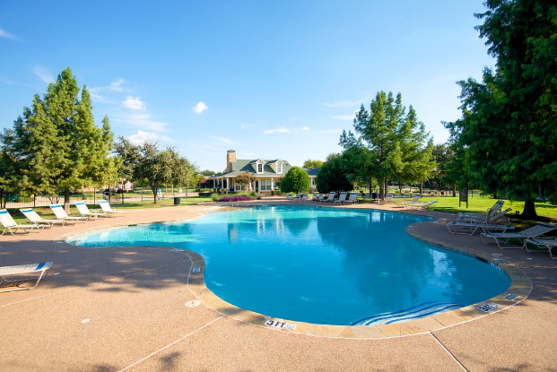

Hey Homestead Residents!
Get ready to swim!! The pool will open Friday, June 5th at 1:30 PM.
The HOA has contacted the City of Carrollton to confirm how the restrictions impact our pool. The City has confirmed that HOA pool is a semi-public pool which must be inspected annually by the City and the HOA must be issued a permit before the pool can open each year. The permit can be revoked for health violations and the pool would then be closed. Currently, the City will allow us to open the pool to 50% of capacity, which must be monitored. The HOA Board has chosen use of a Pool Monitor to ensure that we remain within the restrictions and do not risk having the pool shut down completely. The Board intends to use the data obtained from the monitor to continually reevaluate the best way to obtain compliance and keep the pool open.
The pool will only be operational while the Pool Ambassador is there, so there is a schedule that you should reference before heading out. The hours were discussed at the open Board meeting on May 18. Input was considered from the homeowners who attended. Your Board of Directors will re-evaluate additional pool hours at the next open Board meeting.
Please be sure to have your pool card to enter and be prepared to sign in with your name/address/time.

POOL WEEKLY SCHEDULE

Mondays-closed
Tuesdays-closed
Wednesdays- 9 AM - 1 PM
Thursdays-1 PM - 5 PM
Fridays-1:30 PM - 9 PM
Saturdays-1:30 PM - 9 PM
Sundays- 1:00 PM - 6 PM

The Pool Ambassador will enforce all pool rules that the Association provides and will also require patrons to act in a respectful and responsible way towards property, equipment, and people while in the pool facility. In emergency situations, the Ambassador will assist in whatever manner is requested by the Association Manager, operating under direction by the Board.

Kind Regards,
Patty Cash

