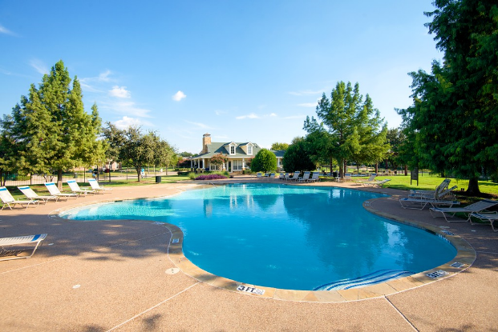

Hey Homestead Residents!
Good news! The pool will open on Friday, June 5th at 1:30 PM. We have hired a company to provide us a Pool Ambassador who will monitor that we operate under the 25% capacity that was ordered by the Governor. The total 25% capacity for our pools is 39. If the 25% capacity is reached, you will not be admitted at that time. The pool will only be operational while the Pool Ambassador is there, so there is a schedule that you should reference before heading out. Please be sure to have your pool card to enter and be prepared to sign in with your name/address/time.

POOL WEEKLY SCHEDULE

Mondays-closed
Tuesdays-closed
Wednesdays- 9 AM - 1 PM
Thursdays-1 PM - 5 PM
Fridays-1:30 PM - 9 PM
Saturdays-1:30 PM - 9 PM
Sundays- 1:00 PM - 6 PM

We do wish the pool was open full-time but for now, while the Governor's order stands, this is the Board has worked out to allow for limited opening. We appreciate your flexibility and support as we navigate through this time. Please extend a warm, Homestead welcome to our Pool Ambassador and let him/her experience the wonderful people that make up the Homestead! Also, please skip coming to the pool if you are not feeling well and practice social distancing with those outside of your household when you are at the pool (see flyer below from the office of the Governor).

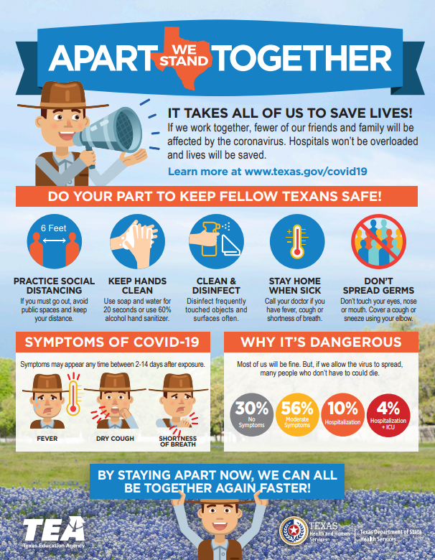

The Pool Ambassador will enforce all pool rules that the Association provides and will also require patrons to act in a respectful and responsible way towards property, equipment, and people while in the pool facility. In emergency situations, the Ambassador will assist in whatever manner is requested by the Association Manager, operating under direction by the Board.

Stay Safe & Healthy,
Patty Cash

